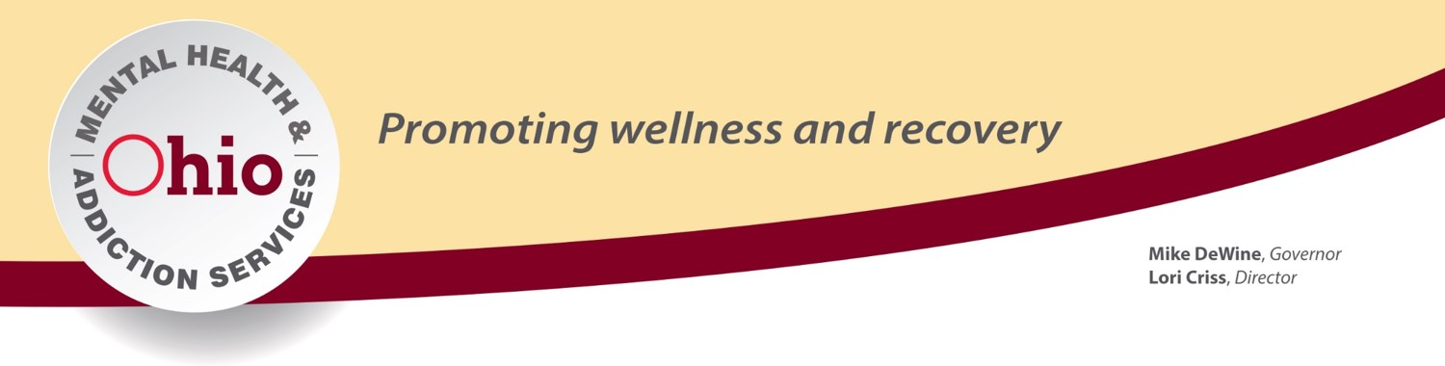

Self-Care Training

Life happens. Not just work but our lives outside of work can cause stress, anxiety and issues that we must deal with to be healthy and happy. Often, our own self-care takes a backseat to taking care of others, completing our work responsibilities and just making it through the day.
This course reminds us that in order to take care of others, we must first, take care of ourselves. The various possible physical, emotional, mental, spiritual and behavioral effects are discussed. Techniques and strategies for dealing with these effects in a healthy and safe way are discussed.
Concepts and techniques for family and friends are also covered. Lastly, resources are provided for additional assistance.
This course can be up to 2 hours or adjusted as time permits. This course is not specific to public safety or first responders but information that would be beneficial for anyone.

Audience: No Limit
Length of Presentation: Adjustable
Format: PowerPoint / Lecture

